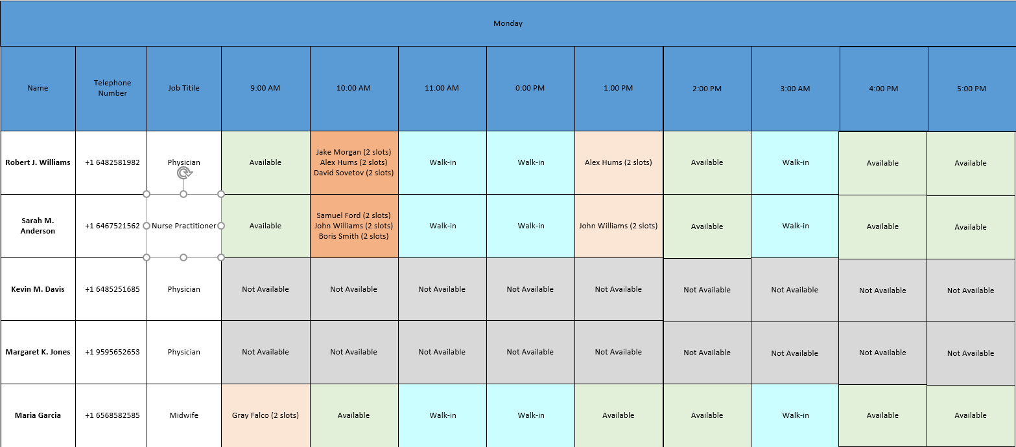

Monday

Name

Telephone Number

Job Titile

9:00 AM

10:00 AM

11:00 AM

0:00 PM

1:00 PM

2:00 PM

3:00 AM

4:00 PM

5:00 PM

**Robert J. Williams**

**+1 6482581982**

Physician

**Available**

Jake Morgan (2 slots)

Alex Hums (2 slots) David Sovetov (2 slots)

Walk-in

Walk-in

Alex Hums (2 slots)

**Available**

Walk-in

**Available**

**Available**

**Sarah M. Anderson**

+1 6467521562

Nurse Practitioner

Available

Samuel Ford (2 slots) John Williams (2 slots) Boris Smith (2 slots)

Walk-in

Walk-in

John Williams (2 slots)

**Available**

Walk-in

**Available**

**Available**

**Kevin M. Davis**

**+1 6485251685**

Physician

**Not Available**

**Not Available**

Not Available

Not Available

Not Available

Not Available

**Not Available**

Not Available

Not Available

**Margaret K. Jones**

**+1 9595652653**

Physician

Not Available

Not Available

Not Available

Not Available

Not Available

Not Available

Not Available

Not Available

Not Available

**Maria Garcia**

**+1 6568582585**

Midwife

Gray Falco (2 slots)

**Available**

Walk-in

Walk-in

**Available**

**Available**

Walk-in

**Available**

**Available**